Management 390 Industry Condition Analysis

Reading 3

E-Book 5 – 17 The external environment

Global strategy in action

* The trend of increasing age in U.S. will be an unfavourable to the youth oriented industry, it would shift their long-range strategy
* A consequence of the changing age distribution of the population has been a sharp increase in the demands made by a growing number of senior citizens
* Fast-food has been labeled as a great concern for obesity and health
* Macdonald’s has a great change in its strategies

Political Factors

* The direction and stability of political factors are a major consideration for managers on formulating company strategy
  + Fair-trade decisions
  + Antitrust laws
  + Tax program
  + Minimum wage
  + Pollution and pricing policies
  + Administrative jawboning
  + Many other protecting employees, consumers, general public, and the environment
* Protection for firms
  + Patent law
  + Government subsidies
  + Product research grants
* Supplier function
  + Government decisions regarding the accessibility of private businesses to government-owned natural resources and national stockpiles of agricultural products will affect profoundly the viability of the strategies of some firms
* Customer function
  + Government demand for products and services can create, sustain, enhance, or eliminate many market opportunities

Technological factors

* Firm must be aware of technological changes that might influence its industry
* Creative technological adaptations can suggest possibilities for new products or for improvements in manufacturing and marketing techniques
* Technological forecasting
  + The quasi-science of anticipating environmental and competitive changes and estimating their importance to an organization’s operations
  + Can help protect and improve the profitability of firms in growing industries

Ecological factors

* Ecology
  + The relationships among human beings and other living things and the air, soil, and water that supports them
* Pollution
  + Threats to life-supporting ecology caused principally by human activities in an industrial society
* Eco-efficiency
  + Company actions that produce more useful goods and services while continuously reducing resource consumption and pollution
* There are four key characteristics of eco-efficient corporations:
  + Eco-efficient firms are proactive, not reactive. Policy is initiated and promoted by business because it is in their own interests and the interest of their customers, not because it is imposed by one or more external forces.
  + Eco-efficiency is designed in, not added on. This characteristic implies that the optimization of eco-efficiency requires every business effort regarding the product and process to internalize the strategy.
  + Flexibility is imperative for eco-efficient strategy implementation. Continuous attention must be paid to technological innovation and market evolution.
  + Eco-efficiency is encompassing, not insular. In the modern global business environment, efforts must cross not only industrial sectors but national and cultural boundaries as well.

Industry Environment

* The general conditions for competition that influence all businesses that provide similar products and services

How competitive forces shape strategy

* The essence of strategy formulation is coping with competition
* Customers, suppliers, potential entrants, and substitute products are all competitors that may be more or less prominent or active depending on the industry
* The collective strength of the five forces determine the ultimate profit potential of an industry
* Corporate strategists’ goal is to find a position in the industry where his or her company can best defend itself against these forces or can influence them in its favor
* They highlight the critical strengths and weaknesses of the company, animate the positioning of the company in its industry, clarify the areas where strategic changes may yield the greatest payoff, and highlight the places where industry trends promise to hold the greatest significance as either opportunities or threats.

Contending forces

* The force determine the profitability of an industry and so are of greatest importance in strategy formulation
* Every industry has an underlying structure, or a set of fundamental economic and technical characteristics

Threat of entry

* Barriers to entry
  + The conditions that a firm must satisfy to enter an industry
* New entrants to an industry bring new capacity, the desire to gain market share, and often substantial resources
* Economics of scale
  + The savings that companies achieve because of increased
  + Cost disadvantage
  + Act as hurdles in distribution, utilization of the sales force, financing, and nearly any other part of a business
  + Important determinant of the intensity of competition in an industry
* Product differentiation
  + The extent to which customers perceive differences among products and services
  + Creates a barrier by forcing entrants to spend heavily to overcome customer loyalty
  + One of the most important barrier in soft drinks
* Capital requirements
  + The need to invest large financial resources to compete creates a barrier to entry, particularly if the capital is required for unrecoverable expenditures in upfront advertising or R&D
  + It is necessary not only for fixed facilities but also for customer credit, inventories, and absorbing start-up losses.
* Cost disadvantages independent of size
* Access to distribution channels
  + The more limited the wholesale or retail channels are and the more that existing competitors have these tied up, the tougher that entry into the industry will be
* Government policy
  + The government can limit or even forceclose entry to industries

E-book 94-98

Ch3 Evaluating a company’s external environment

* 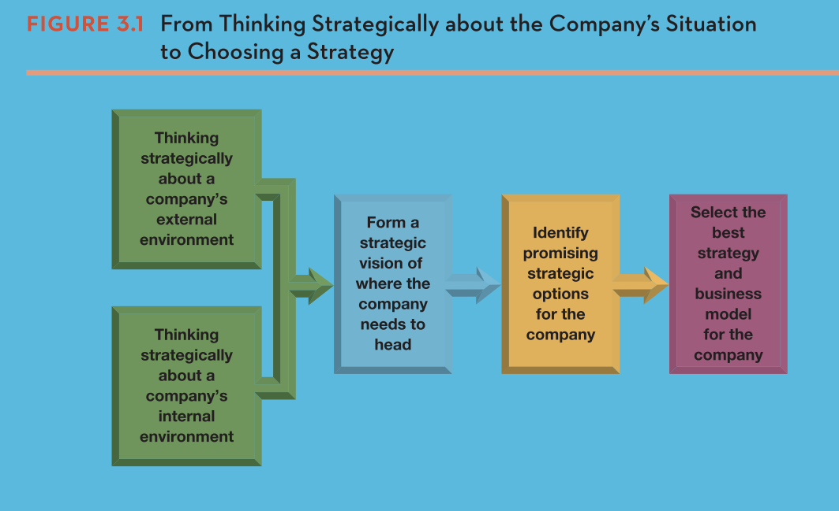

What are the strategically relevant factors in the macro-environment

* Macro-environment
  + Encompasses the broad environmental context in which a company’s industry is suited
    - Political
    - Economic
    - Local
    - Sociocultural
    - Technological
    - Environmental
    - Legal regulatory
* PESTEL analysis
  + Focuses on the six principal components of strategic significance in the macro-environment: political, economic, social, technological, environmental ,and legal forces
  + It is important for managers to determine which of these represent the most strategically relevant factors outside the firm’s industry boundaries
  + Strategically relevant
    - Important enough to have a bearing on the decisions the company ultimately makes about its long-term direction, objectives, strategy, and business model
  + As company managers scan the external environment, they must be alert for potentially important outer-ring developments, assess their impact and influence, and adapt the company’s direction and strategy as needed.
  + A company’s environment having the biggest strategy-shaping impact typically pertain to the company’s industry and competitive environment that we concentrate the bulk of our attention.